**Adventist University of Central Africa (AUCA)**

**SMART CRIME SCENE EVIDENCES ANALYSIS**

Case Study: RWANDA INVESTIGATION BUREAU (RIB)

**A project**

**Presented in partial fulfillment of requirements**

**For degree of**

**BACHELOR OF SCIENCE IN INFORMATION TECHNOLOGY**

**Major in**

**SOFTWARE ENGINEERING**

**By**

**MUGABO Yves**

**May, 2022**

**PROJECT ABSTRACT**

Project for Bachelor Degree in Information Technology

Emphasis in Software Engineering

Adventist University of Central Africa

**TOPIC: SMART CRIME SCENE EVIDENCES ANALYSIS**

**Name of this researcher:** MUGABO Yves

**Name of faculty Advisor:** Mr. MANIRAHO Laurent

**Date Completed**: May, 2022.

As long as people have existed, crime has been a part of human experience. Crime is regional. It takes happen in a particular location at a certain time for a particular reason. Everybody and anyone can be impacted at any time.

main purpose of this project is focused on design of Smart Crime Scene Evidences Analysisprojects which will be a good tool to analyze evidences, make decisions and to easily find out primary suspects based on new evidence and criminal record of suspect.

Briefly this system will help RIB stations to record suspects to a certain case and attach evidences found at crime scene based on past criminal record and present evidences of specific suspected person, system will present primary suspect to the RIB user logged into system

se are following Technologies and tools used:

In order to run Smart Crime Scene Evidences AnalysisSystem onserver side we need:

* Python 3.7 installed in environment variables in local computer.
* Django 2.2 installed.
* PostgreSQL for backend database, which is able to serve as data store
* Visual Studio Code as Integrated Development Environment (IDE) for many programming languages.

**DECLARATION**

I, **MUGABO Yves** hereby state that, to the best of my knowledge, this work was created by me and has not previously been approved for academic credit at this University or any other institution.

**Student**

**MUGABO Yves**

**Signature**: ……………………….

**Date**: ……/…………/…….…...

**APPROVAL**

I, **Mr. MANIRAHO Laurent** hereby attest that this project report was completed with my approval and under my direction.

**Signature: ……………………………….**

**Date: …………/……………/…………….**

**DEDICATION**

This project is dedicated to my family.

because of their support during the entirety of my education.

Additionally, I devote it to all of my friends, especially the AUCA students.

Not only that, I dedicate this work to my boss in appreciation of his mentorship.

TABLE OF CONTENT

PROJECT ABSTRACT i

DECLARATION i

APPROVAL i

DEDICATION ii

LIST OF FIGURES vi

LIST OF TABLES vii

LIST OF ABBREVIATIONS viii

ACKNOWLEDGEMENT ix

DEFINITION OF KEY TERMS x

CHAPTER 1 1

GENERAL INTRODUCTION 1

Background of Study 2

Statement of Problem 2

Objective of Project 3

General Objective 3

Specific Objectives 3

Scope of Study 4

Observation 4

Documentation 4

Interview 5

Expected Results 5

Organization of Report 6

CHAPTER 2 7

ANALYSIS OF CURRENT SYSTEM 7

Introduction 7

Description of Current System Environment 7

Who is RIB? 8

Historical background 9

Mission 9

Vision 9

Description of Current System 10

Analysis of Current System 10

Weakness of Current System 10

Modelling Current System 11

Problems of current system 11

Proposed Solutions 12

System Requirement 12

Functional Requirements 12

Non-functional requirements 13

CHAPTER 3 14

REQUIREMENTS ANALYSIS AND DESIGN OF NEW SYSTEM 14

Introduction 14

Analysis and Design Methodology 14

Object Oriented Methodology (OOM) 14

Unified Modelling Language (UML) 15

UML Models 15

Analysis of new system 15

Requirement Analysis 16

Design of New System 16

Use Case Diagram 16

Use case description 18

Class diagram 25

Sequence diagram 30

Diagram for Sequence Diagrams 31

Activity Diagram 39

Database schema diagram 42

Information design 43

User table 43

Group table 43

RIB Headquarter Table 44

RIB Station Table 44

Station User Table 45

Officer Table 46

Case Table 46

Suspect Table 47

Evidence Table 48

User Table 48

System Architecture Design 49

CHAPTER 4 51

IMPLEMENTATION AND PRESENTATION OF NEW SYSTEM 51

Introduction 51

Technologies used 51

Presentation of New System 52

Software Testing 57

Unit Test 57

Integration test 57

Validation test 58

Hardware and software requirement compatibility 58

CHAPTER 5 59

CONCLUSION AND RECOMMENDATIONS 59

Conclusion 59

Recommendations 60

REFERENCES 61

Books 61

Websites 61

APPENDIX 62

CURRICULUM VITAE 63

# **LIST OF FIGURES**

Figure 1: Organisation Structure 8

Figure 2: Modelling Current System 11

Figure 3: Use Case Diagram 17

Figure 4: Class Diagram 29

Figure 5: Sequence diagram for login request 31

Figure 6 : Sequence Diagram to Create user Account 32

Figure 7 : Sequence Diagram to Add case 33

Figure 8 : Sequence Diagram to Add suspect 34

Figure 9: Sequence Diagram to Add evidence 35

Figure 10 : Sequence Diagram to View Suspect 36

Figure 11 : Sequence Diagram to Manage RIB Station 37

Figure 12 : Sequence Diagram to View primary suspect 37

Figure 13 : Sequence Diagram to the RIB Station Reports 38

Figure 14 : Sequence Diagram to Generate Report 38

Figure 15 : Send request and getting response Activity Diagram 40

Figure 16 : Login activity diagram 40

Figure 17 : User registration activity diagram 41

Figure 18 : Database Schema 42

Figure 19: Index Page 52

Figure 20 : Login Form 52

Figure 21: Add Case 53

Figure 22: Add Suspect 53

Figure 23: Head quarter Dashboard 54

Figure 24: RIB Station Dashboard 54

Figure 25: Station User Dashboard 55

Figure 26 : Generate Report 55

Figure 27 : RIB Report comparison 56

Figure 28: RIB Station Report 56

# **LIST OF TABLES**

Table 1 : Create Account 18

Table 2 : Add Case 19

Table 3 : Add Suspect 20

Table 4 : Add Evidence 21

Table 5: View Suspect 21

Table 6: Manage Rib Station 22

Table 7: View Criminal Record 23

Table 8: View Primary Suspect 23

Table 9: Add Question/Answer 24

Table 10: View Rib Station Reports 24

Table 11: Generate Reports 25

Table 12 : Group Table 43

Table 13 : Group Table 43

Table 14 : Rib Headquarter Table 44

Table 15 : Rib Station Table 44

Table 16 : Station User Table 45

Table 17 : Officer Table 46

Table 18 : Case Table 46

Table 19 : Suspect Table 47

Table 20: Evidence Table 48

Table 21 : User Table 48

# **LIST OF ABBREVIATIONS**

**AUCA** Adventist University of Central Africa

**CSS**  Cascading Style sheet

**DBMS** Database Management System

**GUI**  Graphical User Interface

**HTML** Hyper Text Mark-up Language

**HTTP**  Hyper Text Transfer Protocol

**ICT**  Information Communication Technology

**IDE**  Integrated Development Environment

**IT**  Information Technology

**OS**  Operating System

**RAM**  Random Access Memory

**RIB**  Rwanda investigation Bureau

**SCSEA**  Smart Crime Scene Evidences Analysis

**SQL** Structured Query Language

**UML** Unified Modelling Language

**XML**  Extensible Mark-up Language

**ACKNOWLEDGEMENT**

My God, the Almighty, deserves all of my praise and gratitude for blessing me with his grace  
throughout my life.

My deepest gratitude goes out to my supervisor, Mr. **MANIRAHO Laurent**, who helped me complete this task, especially for his insightful counsel, helpful support, direction, and priceless ideas.

I extend my gratitude to the leadership of Adventist University of Central Africa and the staff personnel of the information technology department.

I am also very grateful and extend my sincere thanks to General Secretary of Rwanda Investigation Bureau for their cooperation by sharing information to make me have time to work on this project and throughout my study.

Finally, special thanks to my family, colleagues and friends for their support, encouragement, friendship and individuals who have provided advice, encouragement, and participation in some form in order for this job to be completed.

God bless you all.

# **DEFINITION OF KEY TERMS**

**System**

An ordered, functional structure called a system is made up of interconnected and interdependent parts (components, entities, factors, members, etc.). To keep system active and functioning and to forward system's objective, se components constantly impact one another (directly or indirectly). A system's limits are often established by system observer. All systems include inputs, outputs, and feedback processes. they also maintain an internal stable state (known as homeostasis) despite a changing external environment. (2005) John Onunga

**Information system**

An information system is an integrated system of parts used to gather, store, process, and deliver information as well as knowledge and digital products. Information systems are essential for businesses and other organizations to run and manage operations, communicate with clients and suppliers, and compete in the marketplace. Electronic markets and inter organizational supply networks are managed by information systems. Leonard M. Jessup and Joseph S. Valacich, 2008

**Database**

A database is a grouping of connected, ordered data. and it will help to store all information relevant to design and implementation of an electronic examination system. information is typically arranged so that it supports processes that ask for it by modeling pertinent features of reality (Robert J. Robbins, 1995).

# **CHAPTER 1**

# **GENERAL INTRODUCTION**

Nowadays society is characterized by increasing levels of global social mobility and uncertainty relating to levels of risk posed by internal and external security threats.

Within this climate security driven by technology is increasingly being used by governments, corporate bodies and individuals to monitor and reduce risk.

Generally, In the world of business, automation is crucial., data analysis and in daily experience. As part of its ongoing objective to improvement of data analysis through information and communication technology (ICT), engineers are working so hard to combine automated devices with organizational tools to create complex systems for a rapidly expanding range of applications.

Both Information Technology (IT) and crime are complex and constantly changing. Social and technological changes introduce new targets, tools and motives for crime. E-crime targets include confidential information, technical infrastructure and denial of service.

Improved and faster technology and worldwide communications make it easier to both organize and hide crime. Above cybercrimes there are many crimes that are not Internet related and use of technology is a solution to crime control complexity.

This project deals with data analysis of crime scene evidences where it refers to presented new evidences of suspect and with suspect criminal records for it to present primary suspected person.

Thus for SMART CRIME SCENE EVIDENCES ANALYSIS information technology can be most advantageous way to be used in crime analysis.

## **Background of Study**

Crime is still one of most challenges that most governments around world are struggling with. Families and businessmen are still being directly or indirectly affected by robberies, murder and other many types of crimes. So, after seeing RIB existing system takes almost 72 hours to present a primary suspect and sometimes reports comes with errors due to human justice which can be easily diverted in one way or another.

This project was designed to offer a method of analysing criminal evidence in order to make these acts easier and more convenient. One of the most important tools is automated crime scene evidence analysis system which consists of tasks such as registering suspects, revising his/her past criminal report compare it with evidences and report summarized report.

Automation is the use of technology to substitute a machine capable of working more rapidly and constantly for a human.

## **Statement of Problem**

Investigation officers still use a physical log book to record crime scene evidences and their human judgement in analysing evidence as well as taking past suspects' criminal records into account when presenting primary suspect, which is a significant problem that slows down faster evidence analysis to present suspect.

Nowadays crime rates are increasing day and night which resulted in having a queues of cases to be analysed and then reporting of primary suspected person will result to:

* Errors in reporting, taking too long and Injustice due to poor of following up criminal.

**Choice and Motivation in Study**

After observing process of finding suspected person among others where some people last in RIB stations for 72hours yet they are innocent. I found that it was not an appropriate way to do so.  
Indeed, that pulled my attention and thus thought I could develop a system that would improve it.  
As an IT student, this was a significant opportunity for me to apply what I had learned during my three years of university education.

It will be a means for my university to fulfil one of AUCA's goals, which is to assist students in becoming contributing members of society; empowered by a desire to advance society, both intellectually and practically, and by a demonstrated interest in doing research projects that advance their nation.

## **Objective of Project**

### **General Objective**

Goal of Smart criminal scene evidences analysis system is typically to eliminate manual, human-based crime scene evidences analysis.

therefore, this new system aims to offer improved crime registration, a better main suspect reporting system on time, and fewer time losses as a result of swift evidence processing employing information technology.

### **Specific Objectives**

Specifically, this project is expected to solve problems found as follow:

1. Analysis of already existing system of crime scene evidences analysis system which is paper-base, knowing problems with that system and impact there are having on crime control and primary suspect.
2. Develop a crime scene evidences analysis system which will be a web-based solution to those problems as it will provide better on time crime reporting and computerized system provides accuracy, security, and reduced redundancy, reduction of work load, backup facilities and faster criminal information retrieval, it will also provide good crime reports to investigation officers.
3. Test of application to be sure that it has solved problems that was re before and make sure that it is able to provide a good crime reporting way to the RIB Station that exclude time spent to investigation offices and other related expenditures and provide crime reports to investigation officers.

## **Scope of Study**

This project in mainly focuses on providing primary suspected person reports about crime scene’ evidences, past criminal record reports of suspect so that Information regarding suspects and evidence must be available to RIB in a quick, accurate, and comprehensive manner. One advantage of automated SCSEA is that the suspect record system will make it easier to get necessary information and is a fantastic tool for RIB improvement by taking actions based on information gathered and system will analyse evidence and past criminal records of suspects and generate reports of primary suspected person to RIB station user. This will solve problem of late and high process of getting primary suspected person from others.

**Methodology and Techniques Used in Study**

After knowing how current system is working, study has got started by researching how crime scene evidences analyses are being done from crime scene to investigation bureau are structured hierarchically according to roles of investigation officers, study has been carried on how different functionalities should be added for better use and improvement in such conditions to minimize time it takes them to find out suspected person.

Without complete knowledge of what occurs within a business or organization during its daily operations, it is impossible to imagine a system of information. To do this, it was required to use a variety of techniques to get the necessary data from users (RIB stations). Three methods of gathering data were used in this study: interviews, documentation, and observation.

### **Observation**

Observation is a systematic data collection. It is action or process of closely observing or monitoring something or someone. To observe, means going deeper in data collected or prolonged engagement in a setting or social situation. Observation is one of methods used to collect information over existing situation, so it has been used to help in this study to collect a lot of information and based on it became very easy to know way existing system were working. As mentioned in definition above one of ways used in this study in understanding flow of work of existing system, an observation in Rwanda Investigation Bureau looking on how y work during crime reporting was made. (technopedia, data collection, 2021)

### **Documentation**

Documentation is something that offers verified facts or proof and acts as a record. also it refers to a group of papers distributed on paper, electronically, or on analog or digital media like CDs or audio tapes. This approach was used to gather information from Rwanda Investigation Bureau files and official papers pertinent to this work. documentation aids in study's familiarization with various tools and approaches to be applied in application development process. process of creating a computerized crime reporting system has greatly benefited from reading more information about how crime reporting is made and seeing all steps that are done to do it. (Data collecting, Technopedia, 2021)

### **Interview**

An interview is a conversation between two or more people where questions are asked by interviewer to elicit facts or statements from interviewee. Thus, in order to attain highly personalized information data about operation of existing system and to better understand process of crime scene evidences analyses in Rwanda Investigation Bureau (RIB) an interview with Investigation Support division was taken and they have explained to me all process of evidence collection and analysis in (RIB) step by step and some of issues they face based on paperwork.

In an interview with Investigator Charles who is in Investigation Support division, I have asked him processes that are followed in crime scene evidences analysis and answer was this; “First reporter has to go/send a call to nearer RIB station, then investigation team will have to show up to crime scene to conduct crime scene evidences, then investigator will have to analyse case evidence with suspects and categorizes case according to crime case category. After all, reporter should fill investigation form where he/she puts there his/her names, name of suspect and place where crime has been occurred to then investigation would start as well as analyzing evidences”.

I have also asked him if there is any problem that they are face while using this system which is manual, and he has answered to me in these words “first problem we are facing is time consuming while recording crime cases and take another time to revise case history of suspects. Not only this problem but also there are other problems with this manual system that we are using which include updating forms when there is a mistake in writing which requires us to overwrite whole information given.

## **Expected Results**

new system will allow following results:

* Human judgement will be turned to Automation with use of Evidences analysis.
* automation of already existing system that will ease entry of records.
* Quick and easy primary suspect reporting.
* Allow Investigator to manage crimes.
* Help Investigation officers to view crime report online and may download it when needed.
* Generate reports about evidences reporter.
* Minimizing human errors in decision making.
* Generate reports about crime cases status.
* system will report all cases that are in each RIB Station.
* Easy to review past criminal records of suspects.
* Generate reports on places where crime has taken place.
* Generate reports on past criminal records of suspects.

**Organization of Report**

This study contains five chapters:

**Chapter one**: describes general topic. It will offer fundamental details about research topic, problems that need to be solved, objectives, study’s scope, methods and strategies, anticipated outcomes, and report organization.

**Chapter two:** Analysis of existing system, which will be the main focus, will outline how the current system operates, as well as its history, vision, and mission. We will also explore significant concerns and provide solutions to those issues.

**Chapter three:** has is often conceptual notion of new system and gets title Requirements analysis and design of new system. It will illustrate how suggested fixes to issues with current system was conceptualized.

**Chapter four:** will place focus on program's technical implementation and presentation of screenshots as forms of data entry and reports, where we will discuss the new system, how the application was created, and the technologies used.

Finally,

**Chapter five** will bring our project to a close and offer suggestions for future improvement..

# **CHAPTER 2**

# **ANALYSIS OF CURRENT SYSTEM**

**Introduction**

As of this chapter, we'll examine current system in terms of how it functions, issues it raises, how those issues affect people's everyday lives, and how system that will eventually be put into place will address them.

Learning about functional and non-functional activities of current system is part of study of system as it is.

A new system is frequently created with intention of replacing an existing manual system with an automated one. suggested solution to difficulties stated in this chapter will be highlighted before it is finished.

This project emphasizes on evidences analysis and suspect reporting system in Rwanda Investigation Bureau.

therefore, we give an overview of evidences analysis and reporting system of suspects in Rwanda.

**Description of Current System Environment**

While making analysis of existing system, we need first to know all about organization that we are working with which is RWANDA INVESTIGATION BUREAU.

It is in charge of crime controls. It is very necessary first take a look at existing environment so that we know history, vision and mission of organization with existing system then know problems faced by it and proposed solution.

The following figure describes the organisation chart of Rwanda Investigation Bureau

**Organization Chart**

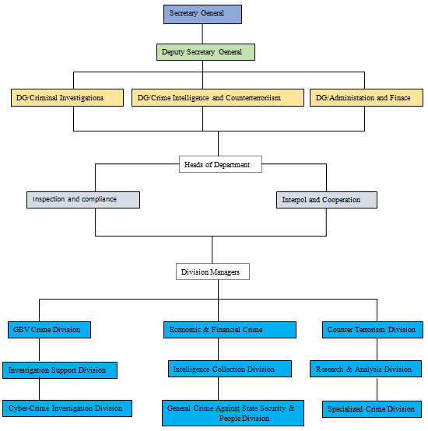

**Figure 1: Organisation Structure**

**Who is RIB?**

The Law No. 12/2017, which went into effect on July 4, 2017, established the Rwanda Investigation Bureau (RIB), an autonomous, specialized body tasked with carrying out career investigative responsibilities, acquiring evidence, and aiding local peace enforcement forces in upholding law and order. Law stipulated that RIB will take over criminal investigative duties as of April 20, 2017, for a customary duration of one year. (RIB, 2021)

**Historical background**

President of the Republic of Rwanda, His Excellency Paul KAGAME, named the Secretary General and Deputy Secretary General of the Bureau on April 9, 2018. On April 10, 2018, At a ceremony overseen by the Head of State, the Secretary General and Deputy Secretary General took their oaths of office. (RIB, 2021)

Following Orders were passed at a cabinet meeting on April 11, 2018, which was presided over by His Excellency Paul KAGAME, President of the Republic of Rwanda:

* Rwanda Investigation Bureau staff's salary and benefits are set forth in a presidential order.
* Rwanda Investigation Bureau's organizational structure was determined by an order from the prime minister.
* Prime Minister’s Order determining modalities of transfer of 463 personnel and assets related to criminal investigation department from Rwanda National Police (RNP) to the Rwanda Investigation Bureau.

Rwanda National Police officially over control of criminal investigations to the RIB on April 18th, 2018, at a ceremony presided over by the Minister of Justice/Attorney General. A website, contact phone numbers, and the logo for RIB were also introduced.

On April 20, 2018, the deadline for changeover set down by legislation, RIB began operating nationwide. Bureau Leadership then started making field visits throughout the nation, beginning in the City of Kigali, to evaluate the preparedness and readiness of RIB station Bureau and staff.

**Mission**

Rwanda Investigation Bureau’s mission is to ensure professionalism, transparency and open-ended independence in criminal investigations with a broad focus on high impact crimes including but not limited to;

* Counter terrorism
* Cybercrime
* Gender based violence
* Public fund embezzlement and corruption
* Human trafficking
* Drug trafficking

**Vision**

To ensure a crime-free society

**Description of Current System**

The current system is manual. Under the current manual technique, all records are kept in written form and kept in various types of registers. A manual system lacks a suitable method for keeping records and preserving data regarding crimes and criminals. This current manual system of RIB is not automated. Criminal records are manually documented. Some suspect, case and evidence files are kept on shelves, while others are piled up in heaps. Due to improper storage, valuable papers quickly become dusty.

**Analysis of Current System**

### **Weakness of Current System**

* **Wasting time of innocent people up to 72hours**

With existing system there are people who stays in RIB Stations for that time yet rib have no evidences but still keeps them there for no reason.

* **Avoid a lot of paper based suspect data classification**

Nowadays, due to fact that data is more important to keep after studies, it becomes a problem because many youths spent a lot of time home doing nothing that can improve them or even worse there is a chance that some of them end up ruining their life.

* **Lack of Statistical reporting due to manual recording system**

re is no easy way to easily generate statistical report

* **Human judgement is at high level**

Some decisions are easy to be diverted due to its basing on human judgement

**Modelling Current System**

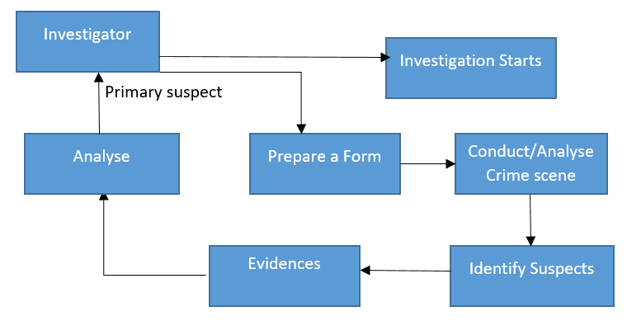

**Figure 2: Modelling Current System**

**Problems of current system**

Fewer of systems that will allow investigation bureaus to easily identify suspected person who committed crimes and other security problems, lack of system which will link current evidences and past criminal records of suspect for providing automation so that investigators will allocate easily identify suspected person among other suspects and be able to provide to m fast emergence judgement to innocent and arrest criminal before spending time being prisoned without guilty, and also make easier follow up to criminals records. On suspects side there is a need to get judgement at real time and with less wastage of time of innocent suspects.

As technology advances, it is now necessary to have a system that will protect RIB from accidents by quickly analysing evidence from criminal scenes. Additionally, if you compare amount of time required to analyse data between two systems (manual and automatic systems), you'll discover that utilizing an automatic system results in more complex changes than using a manual one.

**Proposed Solutions**

Smart crime scene evidences analysis system will make it possible for RIB to look into and analyse evidence from crime scenes for quick criminal follow-up.

It will also make it possible for investigators to track criminal records and crime scene evidence in real time.

proposed solution is to provide system that help RIB to deal with above problems.

* **RIB Headquarter admin will add all possible questions or answers in system**: this will allow rib investigators to use them while asking suspects and witness respective question on a certain case.
* **Easy crimes follow up on criminals.**
* **It will also help investigators in general to monitor criminal records:**  this will happen more easily because each investigator will be assigned to a certain case to be followed
* **Crime evidences analysis at real time:**

Crime evidences will be stored in our database for future reference.

* **Easy Searching method:**
* re will be an option of searching any group according to group-name.

**System Requirement**

**Functional Requirements**

* system must only let logging in with a legitimate username and password.
* user should be able to generate a report in pdf formats.
* Once a new password is required, system ought to be able to provide it.
* system must be able to retrieve information from database.
* y system must be able to validate while entering information.
* User logs must be retained by system.
* Primary suspected person must be presented within 48hours.
* Generate reports about crimes, cases and primary suspected person.

**Non-functional requirements**

* **Security:**
* User-sensitive information must be able to be hidden by the system.
* User passwords need to include characters, numbers and symbols.
* User passwords must be encrypted by the system.
* User must first log in before performing any helpful actions.
* **User friendly:**
* A user-friendly system is required
* system must be simple to use.
* **Privacy:**
* Privacy of users will be protected by this new system.
* **Availability:**
* This new system must be highly available.
* This new system should not experience unplanned downtime
* Maximum monthly downtime for this new system shall be 3 hours.
* **Performance:**
* Within 10 seconds, the new system must fulfill user requests.
* If system is down, no longer than 25 seconds should pass.
* system must be running 24/7.
* **Accessibility:**
* system needs to be mobile or laptop accessible.
* Authorized users must be able to access system.

# **CHAPTER 3**

# **REQUIREMENTS ANALYSIS AND DESIGN OF NEW SYSTEM**

## **Introduction**

A solid foundation will always result in a solid output, and same is true of system concept. You can only create an ideal and practical system when you have a solid analysis and a clear design. In reality, a new system's primary objective is to fulfil demands of its users by resolving issues they have with old one. majority of time, thorough user needs research will result in helpful software development because no method can guarantee a faultless outcome.

The two primary components of system development are:

* System Analysis
* System Design

system is broken down into its component parts during system analysis process, which also involves gathering and interpreting data, identifying issues, and determining problems. In order to determine a system's goals, system analysis is done in order to investigate system. It is a way of problem-solving that strengthens the system and ensures that every component performs well in order to carry out its intended function. Analysis determines how the system behaves.

System design is the process of defining a new business system's components or modules to meet specified needs, or replacing an existing system. Before making any plans, it is important to fully comprehend the current system and decide how computers may be used to work effectively, address a particular problem, and achieve a particular objective. The main focus of system design is attaining the system's objective. The main components of system analysis and design are systems, processes, and technology. (System Analysis and Design Overview, Tutorials Point, 2021)

We considered it crucial to comprehend data flow through that system in order to properly analyse and develop our new system.

**Analysis and Design Methodology**

**Object Oriented Methodology (OOM)**

Information system development can be done using a variety of approaches, including prototyping, object-oriented development, and data structure-oriented development. Object Oriented will be focus of our discussion.

Object Oriented Methodology (OOM) is a method of developing systems that promotes and facilitates the reuse of software components. By building a computer system piece by piece, this methodology promotes efficient reuse of current components and makes it easier for other systems to share its components.

Classes and objects are the two main essential building blocks that are useful in the development of systems using object-oriented approach.

**Object**: is employed to describe a specific instance of a class, where object may consist of a variety of distinct variables, functions, and data structures. Anything, any idea, or any occurrence can be an object.

**Class**: it describes a group of items that share characteristics and actions. A class is divided in three parts as shown below:

|  |
| --- |
| **Class Name** |
| Attributes |
| Operations () |

* Class name is displayed on the upper part.
* middle section includes a class attribute.
* final section provides a method.

An attribute is a named property of a class that specifies the range of values that instances of the property may contain. A method is implementation of a service that can be requested from any object to class to affect behaviour.

**Unified Modelling Language (UML)**

Unified Modelling Language aims to provide a standardized technique for visualizing system designs and is a general-purpose, developmental modelling language used in the field of software engineering. language provides us with the symbols we need to build models, and it is designed specifically to be used with CASE (computer-assisted software engineering) tools. Naturally, the components of a UML model imply some features of technique, however UML is merely a visual syntax that we can use to build models. It does not give us any kind of modelling methodology.

**UML Models**

A **model** a thing used as a model for imitation or imitation. Because a model only depicts most important parts of reality while excluding unnecessary ones, it is simpler to refer to a model than to the reality. class diagrams, sequence diagrams and use case diagrams are just a few of the many possible models that UML offers for a system.

Actually, making all of a system's models is not necessary, but modelling ones that will allow for adequate system visualization is encouraged.

**Analysis of new system**

The analysis phase provides answers to the following queries: who will use the system, what will it do, and where and when will it be used. In this phase, the project's inventor looks into any existing systems that were previously investigated in the second chapter, seeks out better opportunities, and also develops the concept for this new system.

**Requirement Analysis**

Requirements analysis, also referred to as "requirements engineering," is the process of determining user expectations for a new or changed product. Se qualities, often referred to as criteria, need to be exact, relevant, and quantifiable. In software engineering, these criteria are occasionally referred to as functional requirements

**Design of New System**

**Use Case Diagram**

Use case diagram illustrates the functionality of a system in terms of actors, their goals as shown by use cases, and linkages between two. The following are components of a use case model:

* **Actor**

An actor defines a role that a third party external entity plays when dealing directly with a system. It could be user role or a role performed by another system that interacts with system.



* **Use Case**

A use case is a series of procedures or actions that usually defines interactions between roles. (known in Unified Modelling Language as an actor) and a system, to achieve a goal and is represented as follows:



* **Relationship**

A UML association symbol that denotes the presence of meaningful connections between actors and use cases.



* **System boundary**

In order to indicate the edge or border of the system being represented, a box is drawn around the use case.

use case in following figure describes how new system functions and stakeholders

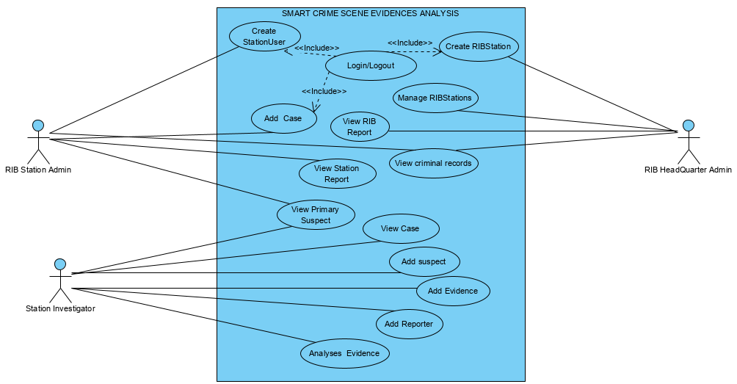

Figure 3: Use Case Diagram

**Use case description**

The use case's description details what it accomplishes and what must be done in order for it to be completed correctly. Each use case appears as follows:

- **Name:** use case's name

- **Description:** aims to accomplish

- **Actor:** actor involved in use case

- **Pre-condition:** condition before starting use case

-  **Post-condition:** state when use case is over

- **Normal flow**: genuine use case steps

- **Alternative flow:** procedures that could be taken if a regular flow were to fail.

1. **Use Case description for Create Account**

|  |
| --- |
| **Name:**  Create User Account |
| **Actor:** RIB Headquarter Admin / RIB Station Admin |
| **Description:** use case describes how actor creates their account for helping them to log in. |
| **Pre-condition:** RIB Headquarter Admin |
| **Post condition:** if the use case is effective user account is created and he/she logs into system, if not system state does not change. |
| **Normal Flow:**   1. use case asks actor to create account if it’s for first time to use system and if not, log in into system with his/her username and password 2. system checks information provided if true account is created. n actor is able to fill username and password. 3. System validates names and password, and if finds correct allow actor to log into system. |
| **Alternative flow:**   * 3. a. system displays an error message when information is not correct. * 3. b. At that moment, the use case terminates, and the actor may choose to return to the start of the main flow or cancel login. |

**Table 1 : Create Account**

1. **Use Case description for Add Case**

|  |
| --- |
| **Name:** Add Case |
| **Actor:** RIB Station Admin |
| **Description:** This use case describes how actors will add all information regarding new cases this includes saving m |
| **Pre-condition:** Actor logging in is required |
| **Post condition:** If use case is successful, case is saved |
| **Normal Flow:**   1. Actors requests a form to add a case. 2. System provides form to fill case information. 3. Actor saves case. |
| **Alternative flow:**   * The system will display an error message if the case information is incorrect. |

**Table 2 : Add Case**

1. **Use Case description for Add suspect**

|  |
| --- |
| **Name:** Add suspect |
| **Actor:** Station Investigator |
| **Description:** This use case describes how actors will add all information regarding new suspect this includes saving m |
| **Pre-condition:** Actors must be logged in and have a valid case assigned to him/her. |
| **Post condition:** If use case is successful, suspect is saved |
| **Normal flow:**   1. Actors requests a form to add a suspect. 2. System provides form to fill suspect information. 3. Actor saves a suspect. |
| **Alternative flow:**   * The system will display an error message if the case information is incorrect. |

**Table 3 : Add Suspect**

1. **Use Case description for Add evidences**

|  |
| --- |
| **Name:** Add evidences |
| **Actor:** Station Investigator |
| **Description:** This use case describes how actors will add all information regarding evidences this includes saving m |
| **Pre-condition:** Actors must be logged in and have case suspects assigned to case |
| **Post condition:** Evidences are savedif use case is successful |
| **Normal flow:**   1. Actors requests a form to add new evidences. 2. System provides form to fill evidences information. 3. Actor saves evidences. |
| **Alternative flow:**   * System will display an error if the information is incorrect. |

**Table 4 : Add evidence**

1. **Use Case description for View suspect**

|  |
| --- |
| **Name:** View suspect |
| **Actor:** Station Investigator, RIB Station Admin, RIB Headquarter Admin |
| **Description:** This use case describes how actors will view all information regarding all case suspect |
| **Pre-condition:** Actors need to be signed in. |
| **Post condition:** You ought to have your case filed. |
| **Normal flow:**   1. Actors requests a form to view suspects of a certain case. 2. System asks user to select a certain case to view its suspects. 3. Actor can view list of suspect. |
| **Alternative flow:**   * If there is no case exists system shows an error. |

**Table 5: View Suspect**

1. **Use Case description for Manage RIB Stations**

|  |
| --- |
| **Name:** Manage RIB Stations |
| **Actor:** RIB Headquarter Admin |
| **Description:** This use case describes how RIB Headquarter will manage all RIB Stations. This includes adding, updating, and deleting from system. |
| **Pre-condition:** RIB Headquarter must be logged in |
| **Post-condition:** If use case is successful, RIB Station is added, updated or deleted from system. |
| **Normal Flow:**   1. When an administrator wants to add, update, or delete a RIB Station from the system, this use case begins. 2. system requests RIB Headquarter to specify function he/she would like to perform i.e. Add, Update, and Delete RIB Station. Once RIB Headquarter provides required information, one of sub-flows are executed:  * Add RIB Station: system requests RIB Headquarter to enter station information, once RIB Headquarter provides requested information, system saves information and RIB Station is added. * Update RIB Station: system requests RIB Headquarter to select from list RIB Stations to be updated. RIB Headquarter selects RIB Station, system retrieves and displays RIB station information, RIB Headquarter makes changes, and record is updated. * Delete RIB Station: Select RIB Station, alter this, system retrieves and displays RIB Station, system prompts RIB Headquarter to confirm deletion, RIB Headquarter verifies deletion, if confirmed deletion is executed. |
| **Alternative flow:**   1. RIB Station not found, if in any sub-flow, station information cannot be obtained; a message is shown. RIB Headquarter has the option to change the name or reverse the case endings. 2. Update Cancelled, if in update station details sub-flow, RIB Headquarter decides not to update station information, update is cancelled and basic flow is restarted at beginning. 3. Remove Cancellation, if in delete station information sub-flow, RIB Headquarters chooses not to remove station data, the delete command is canceled, and the initial basic flow is resumed. |

**Table 6: Manage RIB Station**

1. **Use Case description for View criminal record**

|  |
| --- |
| **Name:** view criminal record |
| **Actor:** RIB Station Admin, Station Investigator |
| **Description:** This use case describes how RIB Station will manage to know past criminal records of suspect. This includes adding, updating his/her records from system. |
| **Pre-condition:** Actors must be logged in |
| **Post condition:** If use case is successful, criminal record information is added, updated from system. |
| **Normal Flow:**   1. When RIB Station wants to add or update suspect criminal records from the system, this use case begins. 2. system asks the RIB Station to indicate the function, such as Add or Update, that they would like to carry out. After RIB Station gives the necessary data, one of the sub-flows is carried out |

**Table 7: View criminal record**

1. **Use Case description for View Primary suspect**

|  |
| --- |
| **Use case:** View primary suspect |
| **Actor:** RIB Station Admin, RIB Headquarter Admin, Station Investigator |
| **Description:** it allows Actors to view primary suspect among or suspects |
| **Precondition(s):** Actors should have logged on system. |
| **Post condition(s):** you should have a valid crime case, suspect and evidences |
| **Normal flow:**   * Actors requests a form to view primary suspected person among or suspects. * System will analyses evidences and based on past criminal records of suspects, it will identify guilty suspect * Actor can view full information of suspect and his/her criminal record. |

**Table 8: View Primary suspect**

1. **Use Case description for Add Questions/Answers**

|  |
| --- |
| **Name:** Add Questions/Answers |
| **Actor:** RIB Headquarter Admin |
| **Description:** allows RIB Headquarter to create questions to be asked suspects and reporters and their predictable answers to RIB Station when investigating |
| **Pre-condition:** RIB Headquarter user must be logged in |
| **Post condition:** RIB Headquarter admin should get a message “Question/Answer has been sent” |
| **Normal flow:**  1. RIB Headquarter requests a form to add question/Answer.  2. System provides question/Answer form.  3. RIB Headquarter user fills and sends question/answer to the RIB Stations.  4. RIB Station receives questions/Answer. |
| **Alternative flow:**   * The system will display an error if the information is incorrect. |

**Table 9: Add Question/Answer**

1. **Use Case description for View** RIB **Station reports**

|  |
| --- |
| **Use case:** View RIB Stations reports |
| **Actor:** RIB Headquarter Admin |
| **Description:** it allows RIB Headquarter to view reports from all RIB stations |
| **Precondition(s):** RIB Headquarter should have logged on system. |
| **Post condition(s): Station’s** Reports are viewed |
| **Normal flow:**   * RIB Headquarter office must log into system * RIB Headquarter can view list of all reports in all RIB stations. * RIB Headquarter saves all station’s reports. |

**Table 10: View RIB Station Reports**

1. **Case description for Generate Reports**

|  |
| --- |
| **Name:** Generate Reports |
| **Actor:** RIB Station Admin |
| **Description:** This use case describes how RIB Station will generate Station Report. |
| **Pre-condition:** A logged-in is required for a RIB Station admin user. |
| **Post condition:** Reports will be produced if the use case is successful. |
| **Normal Flow:**   1. RIB Station is one who has privilege of downloading reports. So after viewing primary suspected person details are being resulted RIB Station will choose option of generating reports. 2. Choose type of Report to be downloaded. 3. Download Report in pdf. |
| **Alternative flow:** If information is not well insert it will be impossible of generating reports and warning message will be displayed. |

**Table 11: Generate Reports**

**Class diagram**

A class diagram is a form of static structural diagram that depicts a system's classes, properties, processes, and relationships between objects to illustrate the structure of the system. Class diagrams address the static design view of a system by displaying a set of classes, interfaces, collaborations, and relationships. The elements of a class diagram are as follows:

**Classes**

An abstraction of entities with similar traits is represented by classes. Associations show how different classes are related to one another.

Draw compartmentalized rectangles to represent classes. Write operations in thirds, list attributes in the second division (left-aligned, not bolded, and lowercase), and center the class name in the first partition.

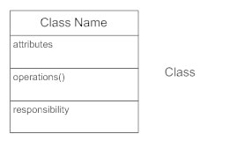

**Active Classes**

In contrast to passive classes, which store data and provide services to other classes, active classes drive the flow of activity.

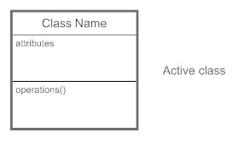

**Visibility**

To indicate who has access to the information in a class, use visibility markers. private visibility, indicated by a - sign, conceals information outside of the class division. Public visibility, denoted with a + sign, enables all other classes to view information that has been marked. Protected visibility, denoted with a # sign, enables access by child classes to data inherited from a parent class.

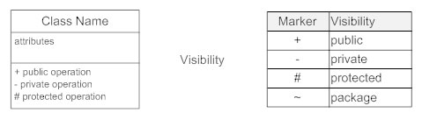

**Associations**

Associations show the fixed connections between classes. Put association names on the association line, above it, or below it. To show relationship direction, use a filled arrow. Position roles near the association's conclusion. Roles illustrate how two classes view one another.

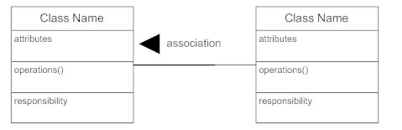

**Multiplicity (Cardinality)**

Near the ends of an association, place multiplicity notations. The SE symbols represent the number of instances of a class that are connected to a single instance of another class.

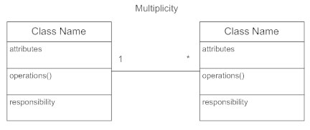

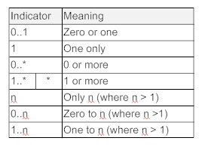

**Constraint**

Constrictions should be put within curly brackets {}.

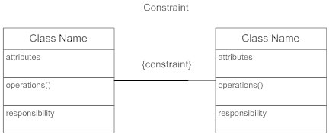

**Composition and Aggregation**

Composition, a distinct form of aggregation, denotes a significant ownership tie between Class A, the total, and Class B, its component. Give a compositional example involving a filled diamond. Use a hollow diamond to symbolize a straightforward aggregation relationship where the "whole" class is more significant than the "part" class but where the two classes are not interdependent. Diamond ends indicate a "full" class in both composition and aggregate relationships.

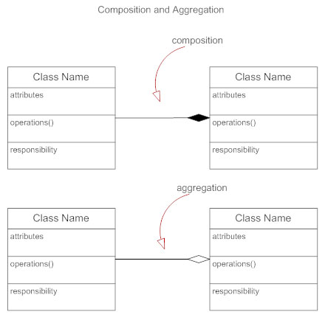

**Generalization**

Generalization is a variant name for inheritance or "is a" relationship When one class is a specialized variation of another, it alludes to the relationship between the two classes.

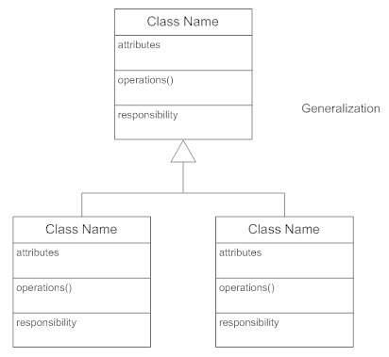

diagram below shows class diagram of new system

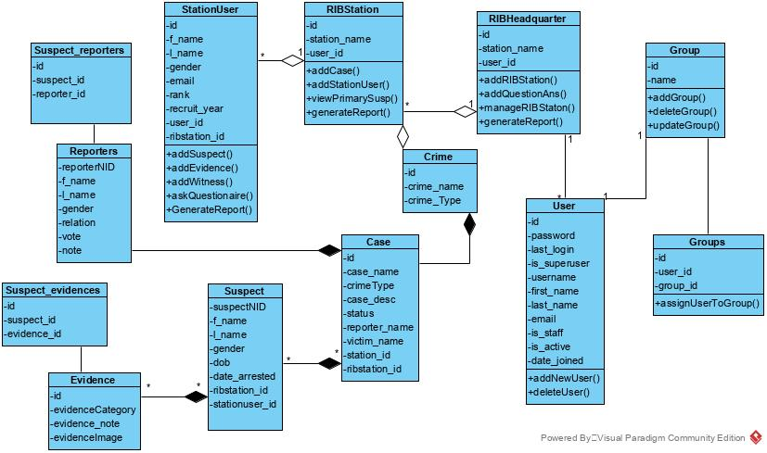

Figure 4: Class Diagram

**Sequence diagram**

An interaction diagram known as a sequence diagram shows how actions are carried out, including which messages are transmitted when and how the timing of sequence diagrams is coordinated. As you scroll down the page, time passes.

The things involved in the communication sequence are listed from left to right depending on when you take part in it. Every vertical dotted line acts as a lifeline, denoting how long an object will survive. Each arrow is a message on the lifeline of the receiver and activation bar is representing duration of execution of that message. The most prevalent type of interaction diagram, known as a sequence diagram, focuses on the communication between several lifelines.

It focuses on the messages that are exchanged in succession and their corresponding occurrence specifications on lifelines to characterize an interaction.

|  |  |
| --- | --- |
| **Definitions and Terms used** | **Their Symbols** |
| **An actor:**   * It could be a system or a person who receives an external benefit from the system. * It joins a series by sending or receiving messages. * Across the top of the diagram, it is located. |  |
| **An object lifeline:**   * Through the sending and receiving of messages, it takes part in a sequence. * It is positioned across the diagram's top. |  |
| **An activation**:   * It has a long, thin rectangle on top of it and is a lifeline. * When an item sends or receives messages, it is indicated by this. |  |
| **A message**:   * It transfers knowledge from one object to another. * A return is indicated by the value being returned and a dashed arrow, whereas an operation call is shown by the message that is being delivered. | : Message send:asynchronous  : Message return  : Message call |

**Diagram for Sequence Diagrams**

**Login request**

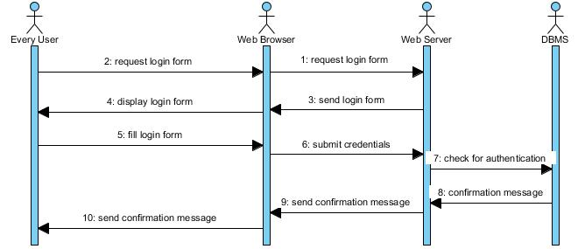

**Figure 5: Sequence diagram for login request**

**Create user Account**

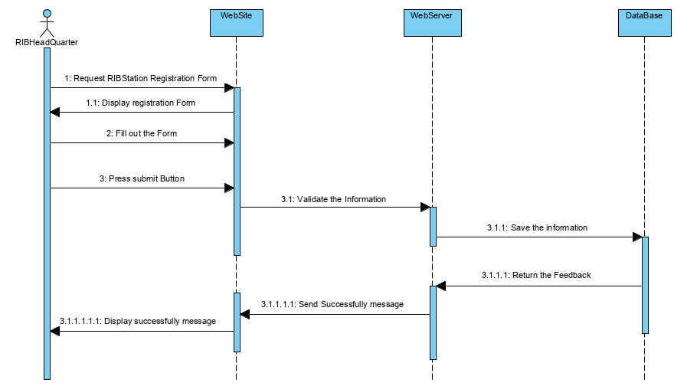

Figure 6 : Sequence Diagram to Create user Account

**Add case**

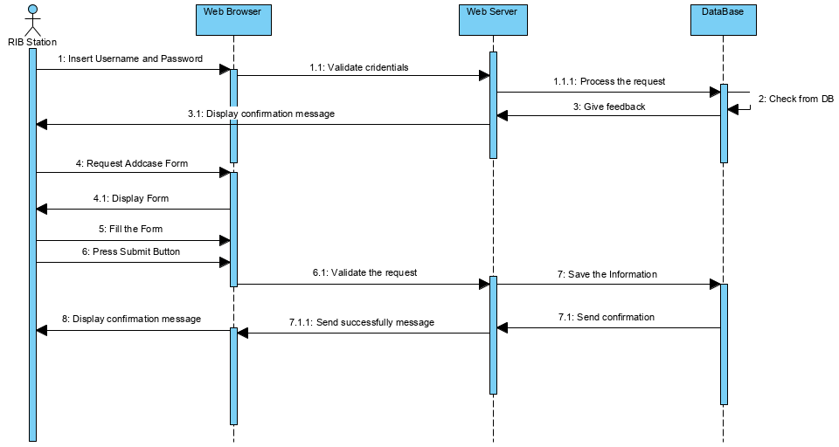

Figure 7 : Sequence Diagram to Add case

**Add Suspect**

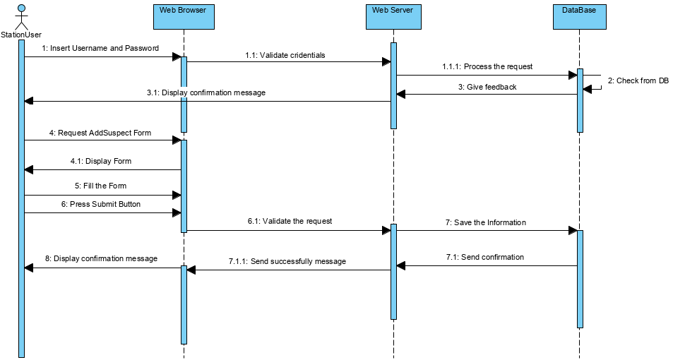

Figure 8 : Sequence Diagram to Add suspect

**Add evidence**

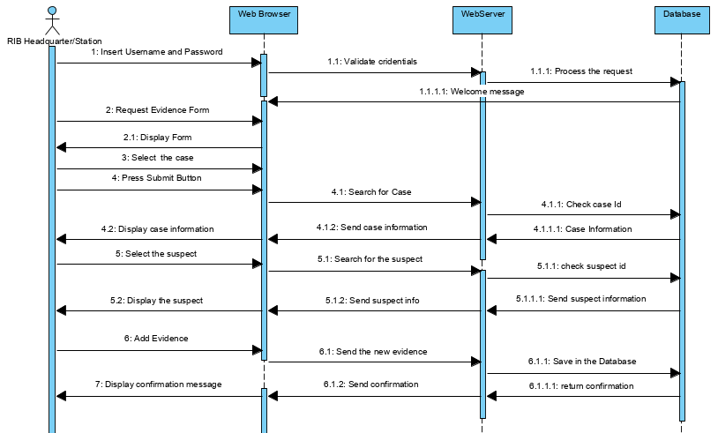

Figure 9: Sequence Diagram to Add evidence

**View Suspect**

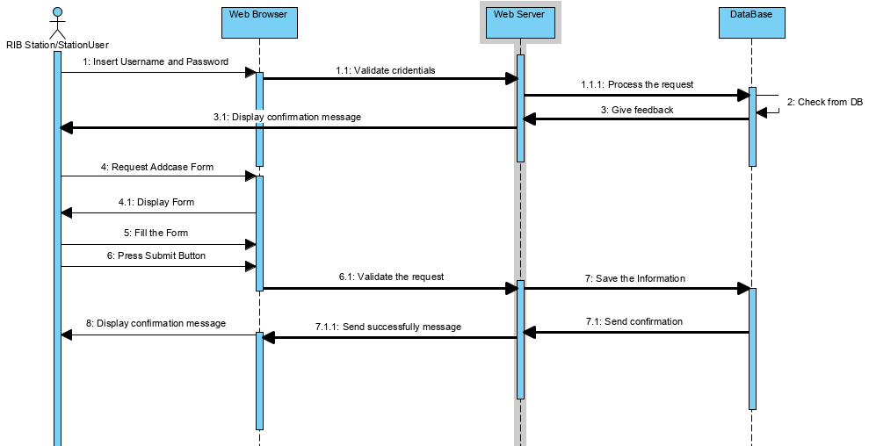

Figure 10 : Sequence Diagram to View Suspect

**Manage RIB Station**

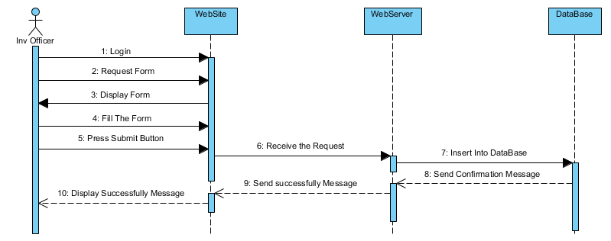

Figure 11 : Sequence Diagram to Manage RIB Station

**View primary suspect**

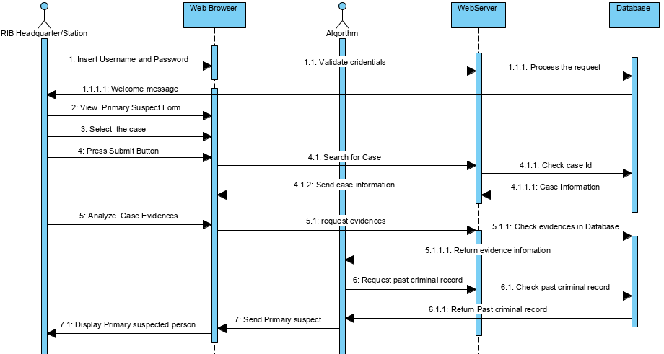

Figure 12 : Sequence Diagram to View primary suspect

**RIB Station Reports**

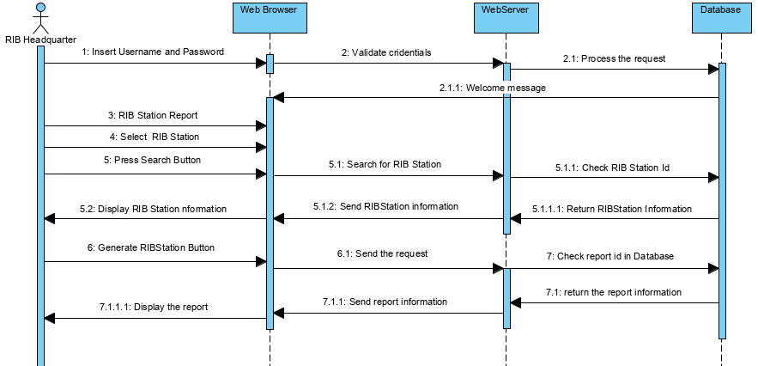

Figure 13 : Sequence Diagram to the RIB Station Reports

**Generate Reports**

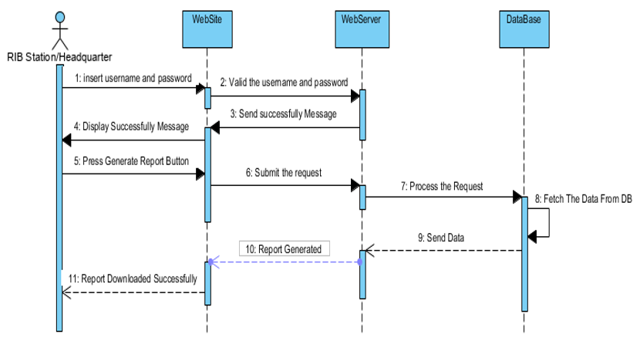

Figure 14 : Sequence Diagram to Generate Report

**Activity Diagram**

**Activity diagrams** are graphical representations of sequential procedures that support choice, iteration, and concurrency. Activity diagrams in Unified Modelling Language are meant to represent both computational and organizational activities. they display the entire control flow. They are also made up of a select few forms joined together by arrows.

primary form categories:



Task is a discrete action that falls under the process umbrella.



Exclusive gate ways (decisions) are points in a business process where the order of events can take two or more different pathways.

Start (split) or end (join) of concurrent activity is represented by bars.



This start event shows where a specific process will begin.



This End event lets you know where a specific process will end.

**Activity diagram for sending request and getting response**

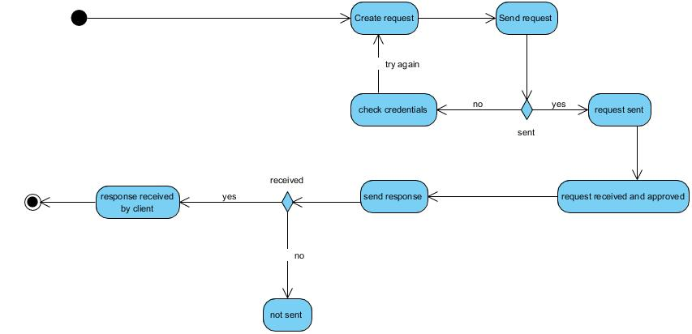

Figure 15 : Send request and getting response Activity Diagram

**Activity diagram for login**

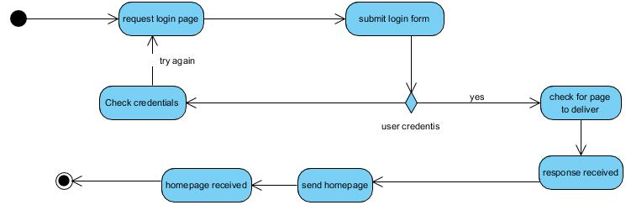

Figure 16 : Login activity diagram

**Activity diagram for RIB Headquarter, RIB Station User Registration**

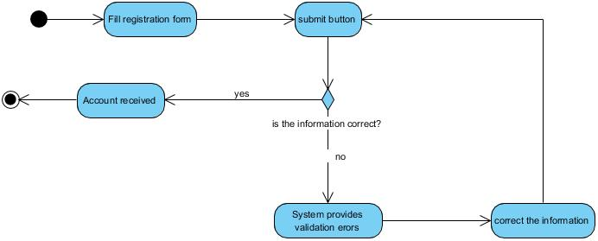

Figure 17 : User registration activity diagram

**Database schema diagram**

A set of data that has been organized such that it can be easily accessed, maintained, and changed is known as a database schema diagram. Data base Management System (DBMS) are referred to as database software tools, and they are mostly used to store, change, extract, and search for data inside of databases.

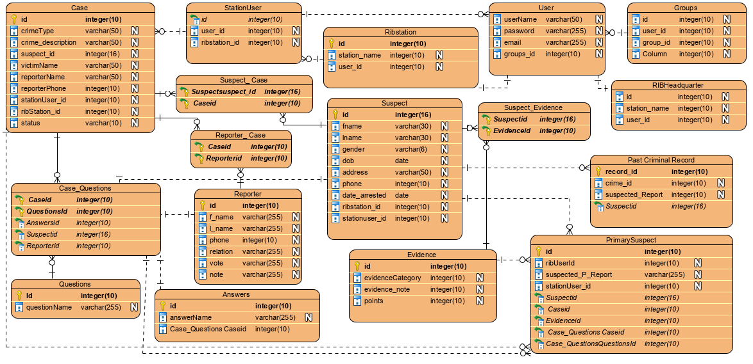

Figure 18 : Database Schema

## 

## **Information design**

Creating a database with user tables, district tables, sector tables, school tables, etc. may be as simple as constructing a set of hyper-linked Web pages. Using a relational database, a set of tables is established to identify various entities. Tables are created using primary keys, and relationships are maintained using foreign keys, preserving the uniqueness of the data fields.

### **User table**

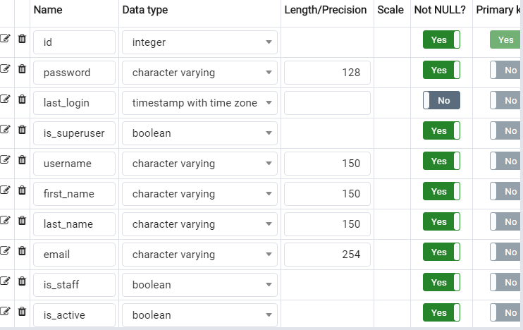

**Table 12 : Group table**

### **Group table**

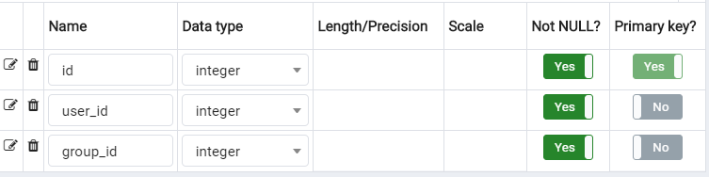

**Table 13 : Group table**

### **RIB Headquarter Table**

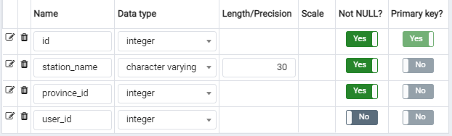

**Table 14 : RIB Headquarter table**

### **RIB Station Table**

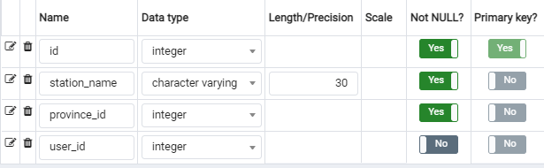

**Table 15 : RIB Station table**

### **Station User Table**

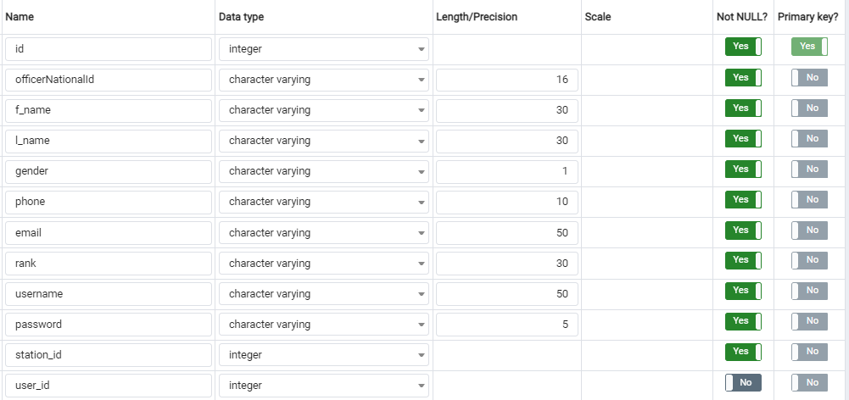

**Table 16 : Station user table**

### **Officer Table**

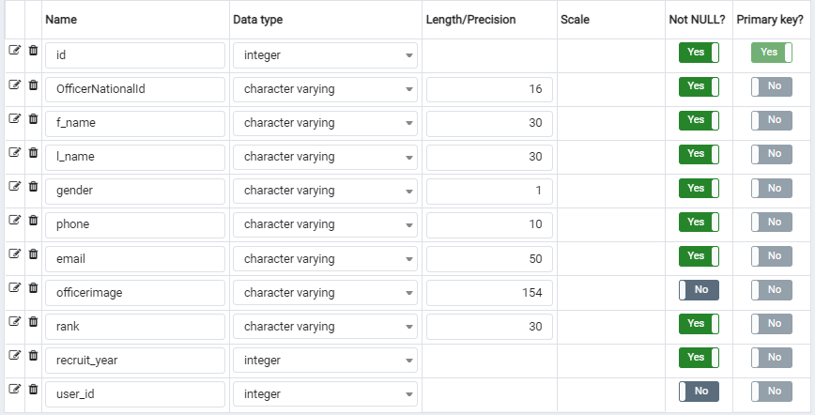

**Table 17 : Officer Table**

### **Case Table**

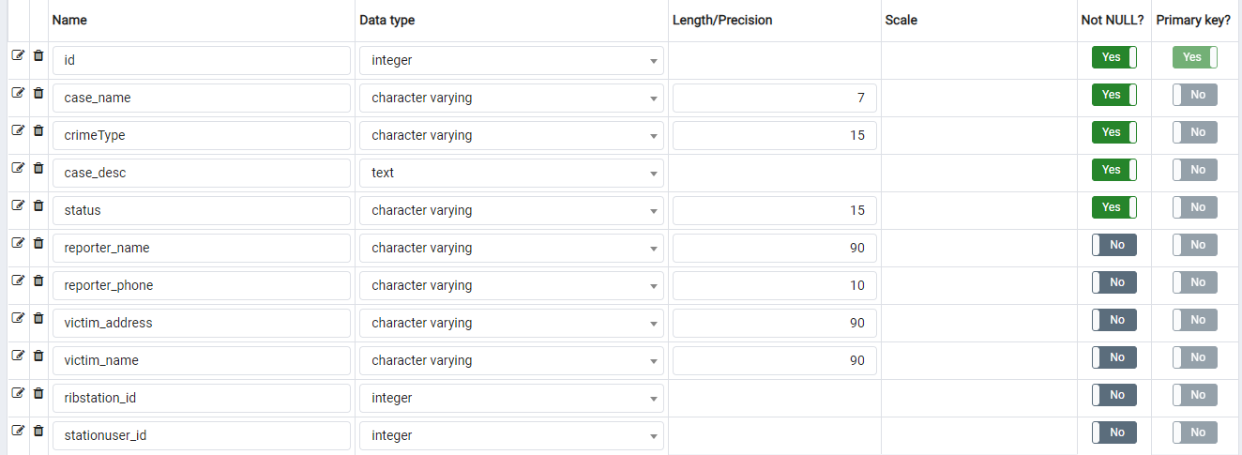

**Table 18 : Case table**

### **Suspect Table**

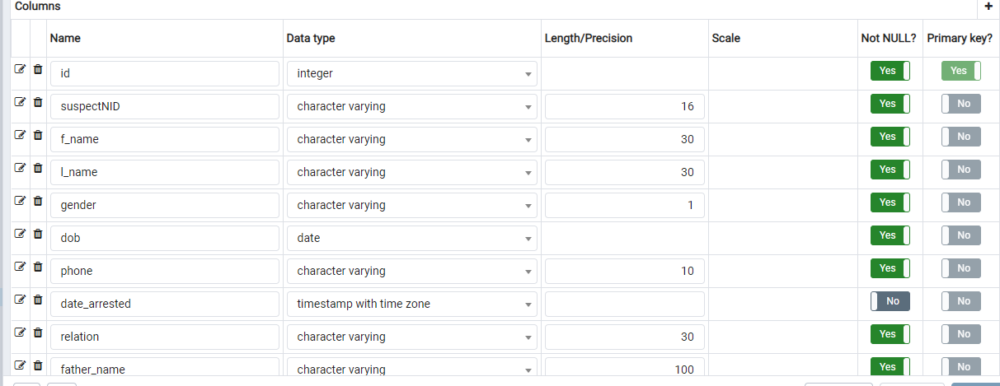

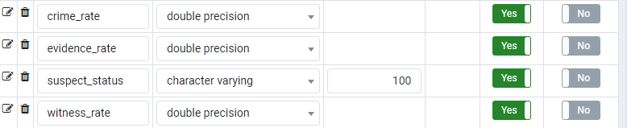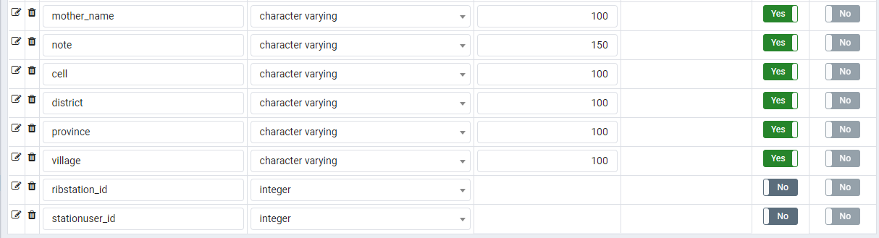

**Table 19 : Suspect table**

### **Evidence Table**

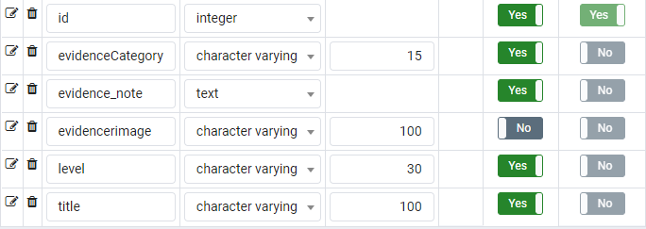

Table 20: Evidence table

### **User Table**

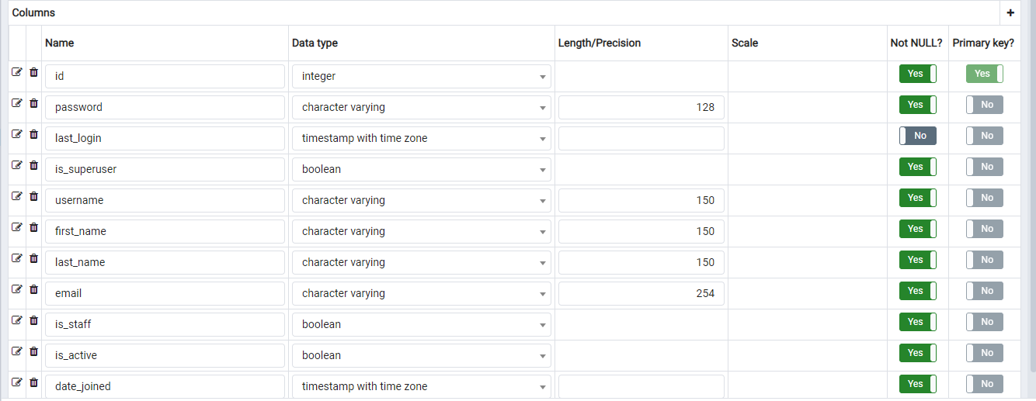

**Table 21 : User table**

## **System Architecture Design**

System architecture is an abstract representation of a system's structure, behavior, and other perspectives. A system's formal description and representation, arranged to facilitate discussion about its structures and actions, is called an architecture description.

**Objectives of architecture design**

1. List essential components of an informational system in order.
2. Explain server-based, client-based, and client–server architectures.
3. Describe modern architectural choices, like cloud computing.
4. Describe how architectural design is impacted by operational, performance, security, cultural and political requirements.
5. Come up with an architectural concept.

following picture represents architecture design of system

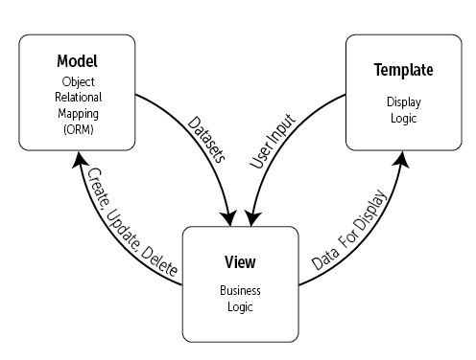

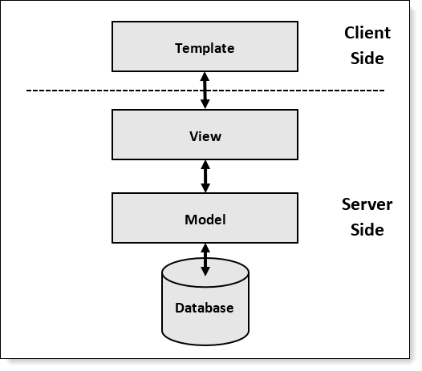

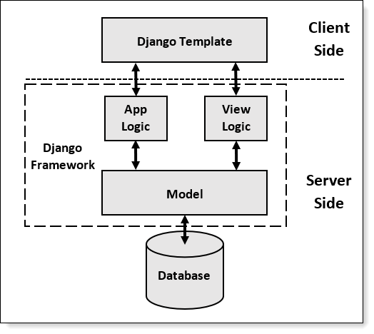

Figure 19: Architecture design of system

# **CHAPTER 4**

# **IMPLEMEN****TATION AND PRESENTATION OF NEW SYSTEM**

**Introduction**

This chapter explains the evolution of “**SMART CRIME SCENE EVIDENCES ANALYSIS**”, It includes a succinct description of the technology utilized in the development of this application, its use, and the testing have already been conducted. Compatibility criteria for software and hardware are last but not least.

## **Technologies used**

**For this application's development, variety of technologies are used, including:**

**Technologies used**

|  |  |
| --- | --- |
| **Technology Software** | **Product** |
| DB(Database) | PostgreSQL |
| IDE (Integrated development environment) | Visual Studio Code |
| programming languages | Python, Django |
|  |  |

**Presentation of New System**

**Index Page**

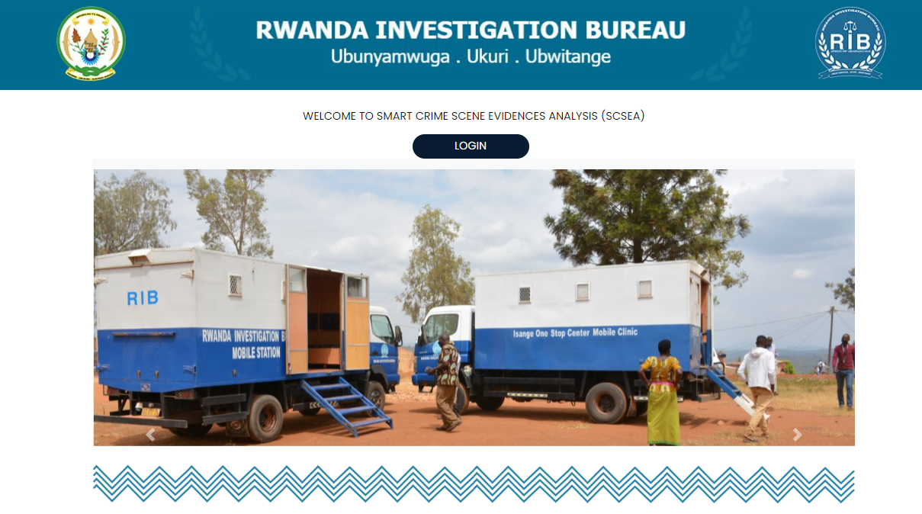

Figure 19: Index Page

**Login Page**

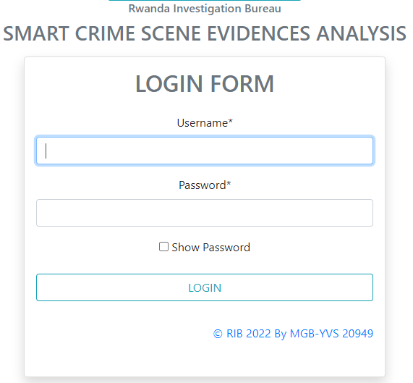

Figure 20 : Login Form

**Add Case**

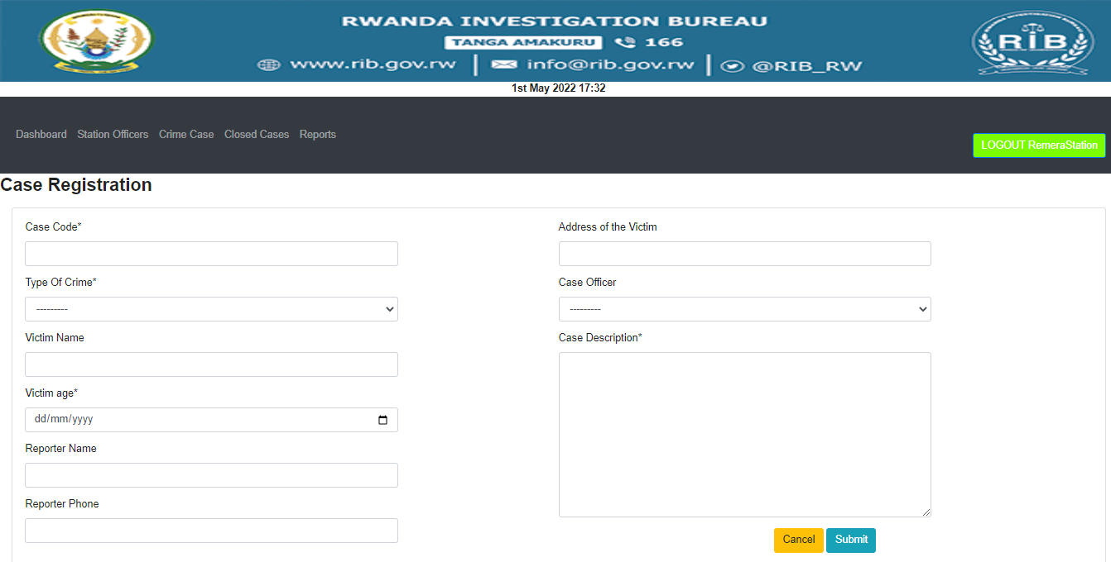

Figure 21: Add Case

**Suspect**

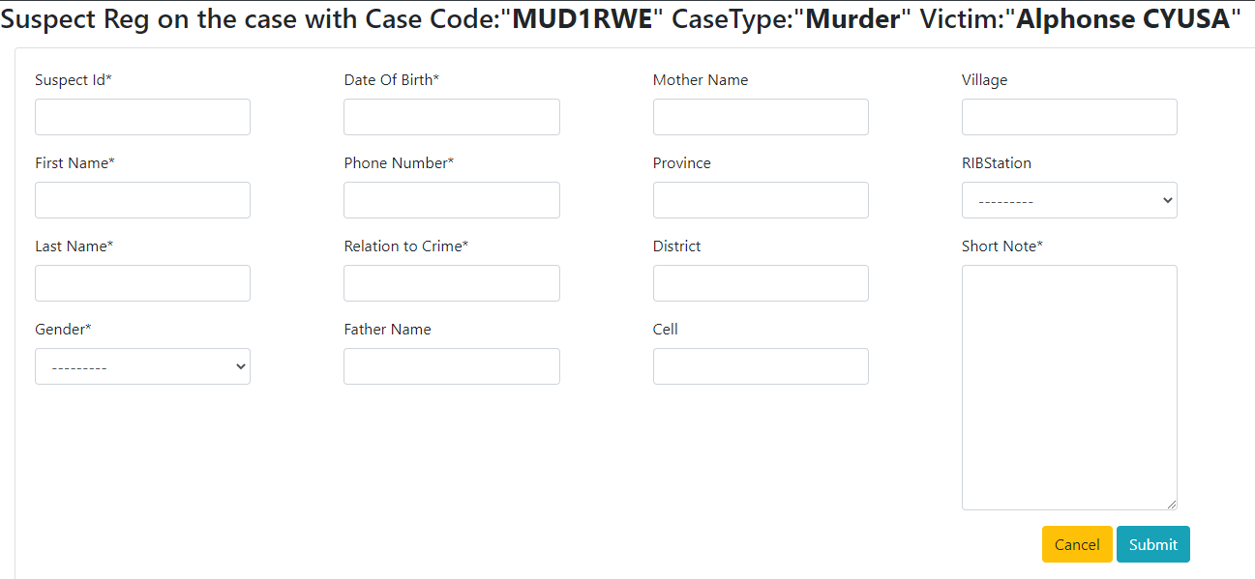

Figure 22: Add Suspect

**Headquarter site**

**Dashboard**

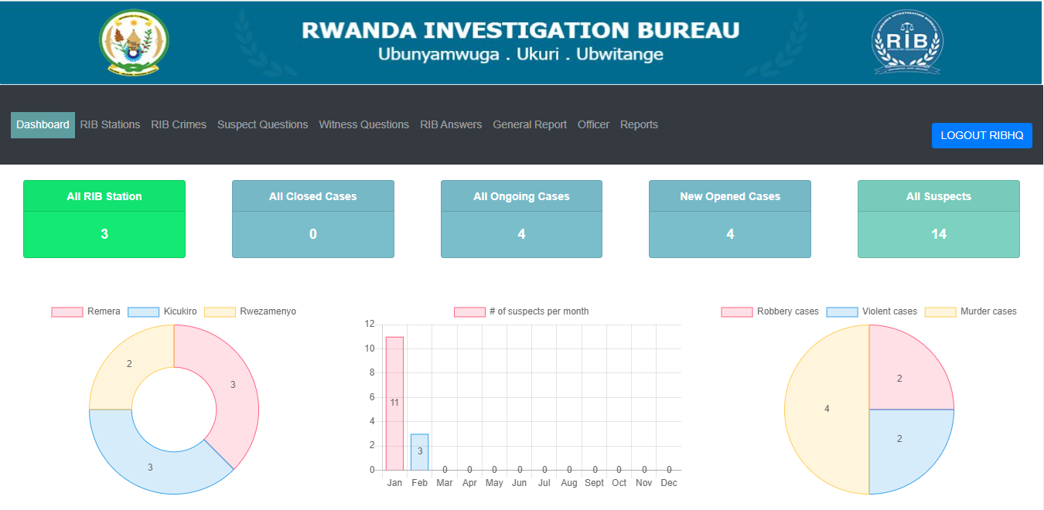

Figure 23: Head quarter Dashboard

**RIB Station Dashboard** 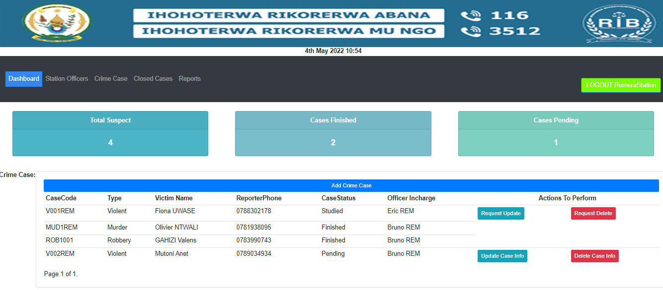

Figure 24: RIB Station Dashboard

**Station user Dashboard**

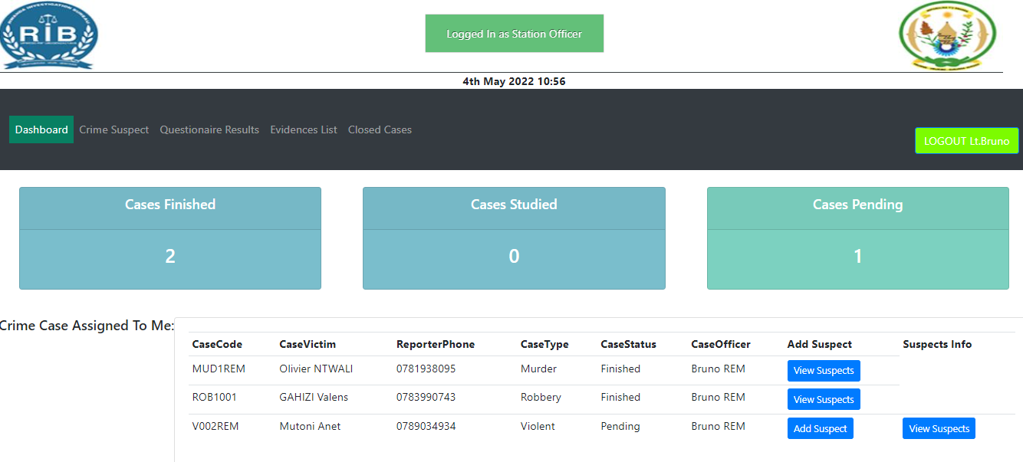

Figure 25: Station User Dashboard

**Generate Report**

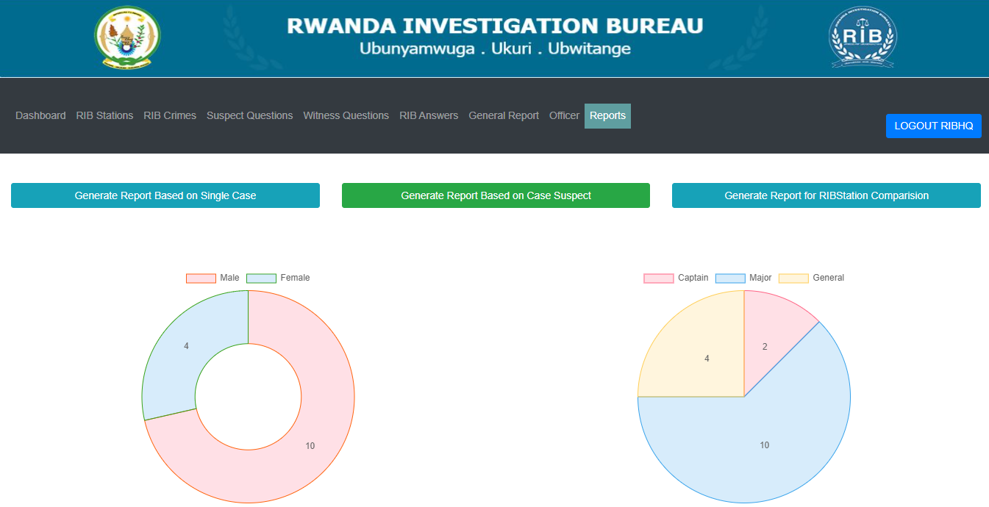

Figure 26 : Generate Report

RIBStation comparison based on cases

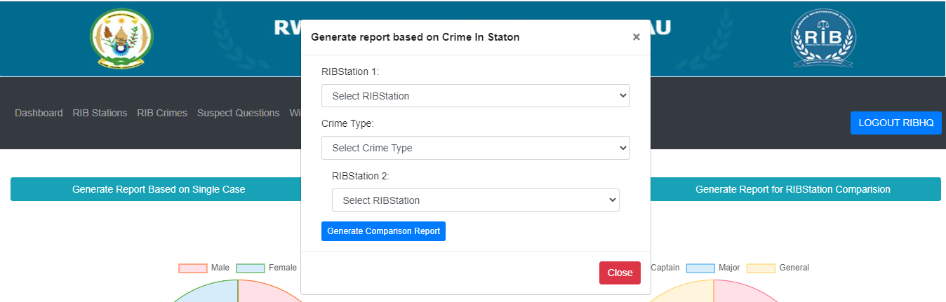

Figure 27 : RIB Report comparison

RIBStation comparison based on cases

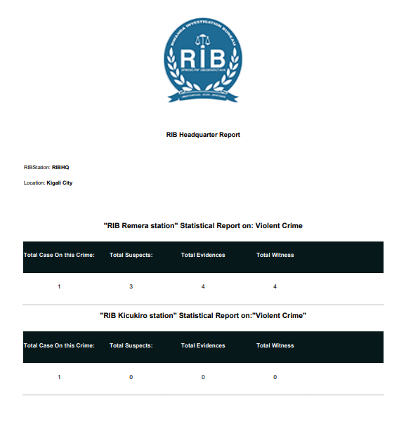

Figure 28: RIB Station Report

**Software Testing**

Software testing is crucial to the design process. They aid in testing software's efficacy to determine whether it genuinely solves the problem it was designed to address.

The following are important factors to think about when performing software testing.:

• Does the application adhere to the specifications that shaped its development and design?

• Does the application function as intended?

• Can application be implemented with same characteristics and satisfies needs of stakeholders?

Here are software testing examples:

**Unit Test**

Unit testing is a procedure to guarantee that a specific piece of software or a section of a program is operating correctly. It is a method for determining if certain pieces of source code, collections of one or more computer program modules, and associated control information, usage guidelines, and operating procedures are appropriate. To put it another way, every tiny part that can be put together with the intention of making sure that each component meets its specifications and testing for logical faults. Indeed, Unit testing is a productive method that enables the most accurate error detection. At the time each piece of code was written, the application underwent unit testing.

**Integration test**

During the software testing process' integration test step, separate software components are merged and tested collectively. This test is helpful for inspecting the assembly of various software components. Additionally, it is a process of tests in which hardware and software parts are gathered and examined till the system is examined. Application modules have been thoroughly tested until they meet all functional and technical requirements. This was done by iteratively testing the integrated software components.

**Validation test**

This last test phase's responsibility is to validate the software in its external environment. The product has been placed in its final environment to ensure that it properly satisfies the needs specified in the initial phase. The importance of the validation test stems from the necessity to confirm that the application's configuration satisfies stated requirements application has been thoroughly tested, and it is thanks to this that we have discovered that the progress of the operations carried out matches the functional criteria.

**Alpha testing**

This kind of validation testing is used. It is a sort of acceptability testing that is carried out prior to the release of the product. People who work in quality assurance often perform it.

**Performance Testing**

This is intended to measure software's performance during runtime in the context of an integrated system. A program's efficiency and speed are tested using this method.  
**Regression Testing**After additional components are added to the entire program, this type of testing ensures that each component continues to function effectively.

**Hardware and software requirement compatibility**

**Client-side requirements:**

* OS (Linux, Windows 10,11, iOS).
* 4 Gigabyte of free space of hard disk.
* A RAM of 2Gigabyte (minimum)
* A web browser (Edge, Google Chrome, Mozilla Firefox, etc.)

**Server-side requirements:**

* A Web server which support Python (Anaconda, etc.);
* Windows server 2012
* PostgreSQL Server or MYSQL SERVER
* Network cark: 1GB/Second;
* 500GB of hard disk space.

# **CHAPTER 5**

# **CONCLUSION AND RECOMMENDATIONS**

## **Conclusion**

The primary goal of the new project was to develop and implement a web project called "SMART CRIME SCENE EVIDENCE ANALYSIS" that would include various services required by suspects and be very user-friendly for them, allowing the Rwandan Investigation Bureau to easily access tools for analysing crime scene evidence.

A variety of techniques and resources were employed in this study effort. For a thorough understanding of the current system, tools like observation, documentation, and interviews have been used.

In fact, the development of this information system helped to further the examination of available evidence.

After receiving problems within our purview, analysis was carried out using UML in order to design a new system utilizing the Django framework for the Python programming language in order to discover an appropriate solution.

With the creation of this system, I intend to cut down on time wastage, prevent misunderstandings, and provide easy data flow and less hard work. I believe that pertinent  
departments, such as RIB stations, Rwanda National Police will have to find this new system as highly convenient and also a reliable information system in order to accomplish their goals

Our hope is that this software SMART CRIME SCENE EVIDENCE ANALYSIS SYSTEM to improve their performance in activity of primary suspect delivery based on crime evidences, and we hope that use of this software will enhance Service of evidence analysis and decision making.

Finally, as a part of my continued participation in the improvement of this work, it is still open to receiving recommendations and addressing any requests that may be directed my way.

## **Recommendations**

The Rwanda Investigation Bureau should train its employees on how to use the new system and what it can do, in order to administer SCSEA using ICT, which is quicker, simpler, and more productive.

Future versions of the application will have a variety of additional features, including the ability to communicate system material in several languages, including French and Kinyarwanda, in order to grow user numbers.

* To department of Schools Grading and Reporting System, it will be better to whoever will use new system be first of all trained how system works and what it does.
* Once a system is established and in operation, I advise creating regular backups of the data on it; doing so will be crucial to preventing data loss.

In putting an end to this effort, we leave the door open for anyone who wants to add to, enhance, or carry out further research on this topic.

# **REFERENCES**

## **Books**

* ARIADNE TRAINING CORPORATE, (2022*).* UML Applied-Object oriented analysis and design using UML, Somerset UK.
* Douglas Bell.(2021).Software Engeneering for Students: A Programming Approach (fourth edition).Addison Wesley.
* Steve Levine, Maria Rodriguez, Geoffrey Thomas. (2022). Web Programming in Python with Django.
* Remez & et al, 2004. Fundamentals of Database Systems. Addison-Wesley

## **Websites**

Elmasri R, N. S. (1994). *Fundamentals of Database Systems,Second edition.* Benjamin/Cummings.

RIB. (2021, May 05). *History*. Retrieved from rib.gov.rw: www.rib.gov.rw/index.php?id=371

Rwanda, R. (2021, March 15). *History*. Retrieved from rib.gov.rw: www.rib.gov.rw/index.php?id=371

smartdraw. (2021, july 14). *class diagram*. Retrieved from smartdraw.com: https://www.smartdraw.com/class-diagram/#classDiagramSymbols

smartdraw. (2021, January 01). *class diagram*. Retrieved from smartdraw.com: https://www.smartdraw.com/class-diagram/#classDiagramSymbols

technopedia. (2021, july 02). *data collection*. Retrieved from technopedia.com: https://www.technopedia.com/definiion/30318/data-collection

technopedia. (2022, January 09). *data collection*. Retrieved from technopedia.com: https://www.technopedia.com/definiion/30318/data-collection

tutorialspoint. (2021, July 17). *System Analysis and Design Overview*. Retrieved from tutorialspoint.com: https://www.tutorialspoint.com/system_analysis_and_design/system_analysis_and_design_overview

tutorialspoint. (2021, August 12). *System Analysis and Design Overview*. Retrieved from tutorialspoint.com: https://www.tutorialspoint.com/system_analysis_and_design/system_analysis_and_design_overview

Wesley A. (2004).

# 

# **APPENDIX**

# **CURRICULUM VITAE**

Name: Yves MUGABO

Address: Gasabo, Kigali, Rwanda

Nationality: Rwanda

Tel: 0784960500

Email: [mugaboyves1@gmail.com](mailto:mugaboyves1@gmail.com)

**Personal Statement_____________________________________________________________**

I am young, energetic and self-motivated person, ready to work and attain results. I strive to  
achieve and value in everything I put my hands on. Honesty and respect at work place, is  
what I put forward, team work and knowledge sharing is what I value.

**Educational background________________________________________________________**

|  |  |  |  |
| --- | --- | --- | --- |
| **Period** | **Level** | **Institution** | **Awards and Relevant courses** |
| 2017-Now | Undergraduate | Adventist University of Central Africa | Bachelor’s degree in Information Technology-Software Engineering |
| 2014-2016 | Advanced Level(A1) | College ACEJ/KARAMA | High school Diploma in Computer science |
| 2010-2013 | Ordinary Level(O’ level) | Lycee de KICUKTHEIRO(APADE) | O’ level certificate |

**Relevant Experience____________________________________________________________**

|  |  |  |
| --- | --- | --- |
| **Year** | **Type of service** | **Place** |
| **(2017-2020)** | **IT Support in MAINTENANCE Department** | **OMEGASTHEIR Ltd** |
| **(2018-2020)** | **Information Technology IT** | **ONCONSULTING GROUP** |
| **(2019-Now)** | **Assistant IS Auditor** | **ON CH Ltd** |
| **(2021-Present)** | **Head of ICT** | **Twyford Rwanda** |

**Awards & Trainings____________________________________________________________**

**January – May 2017:** Trained in computer maintenance and MS-Office professional use and library configuration and troubleshooting problemsat TNT Academy.

**May – August 2017:** Trained in Leadership style at New Life Ministries

**January– March 2020:** Trained in IS Auditing at ONTECH Ltd

**January– March 2022:** ICDL Certificate at Skills Hub International

**Skills_________________________________________________________________________**

|  |  |
| --- | --- |
| Language skills | Able to speak/write English, Kinyarwanda and French. |
| Technical skills | In computer, I am able to use PostgreSQL in database, and to code using Python, php, Java language and JavaScript in designing software. |
| Professional skills | I am able to lead different people and negotiate with m. |
| Interpersonal skills | I am sociable, team player. |

**Hobbies/Interests_______________________________________________________________**

-Reading books.

-Using different new application on my computer.

**Declaration____________________________________________________________________**

I declare that information provided above is authentic and correct to best of my knowledge and belief.

**References____________________________________________________________________**

-Olivier NTAWUYTHEIRUSHINTEGE

[Tel:078](Tel:0781440377)8303061

-Yves NIYITEGEKA

[Tel:07](Tel:0788408527)88307479